Family visit
Their great-grandfather once emigrated from Wipperfürth to the USA
Translation of article by Stefan Corssen, Kölnische Rundschau, 28 July 2026

Original article (in German):
Familienbesuch Ihr Urgroßvater wanderte einst aus Wipperfürth in die USA aus - Rundschau Online
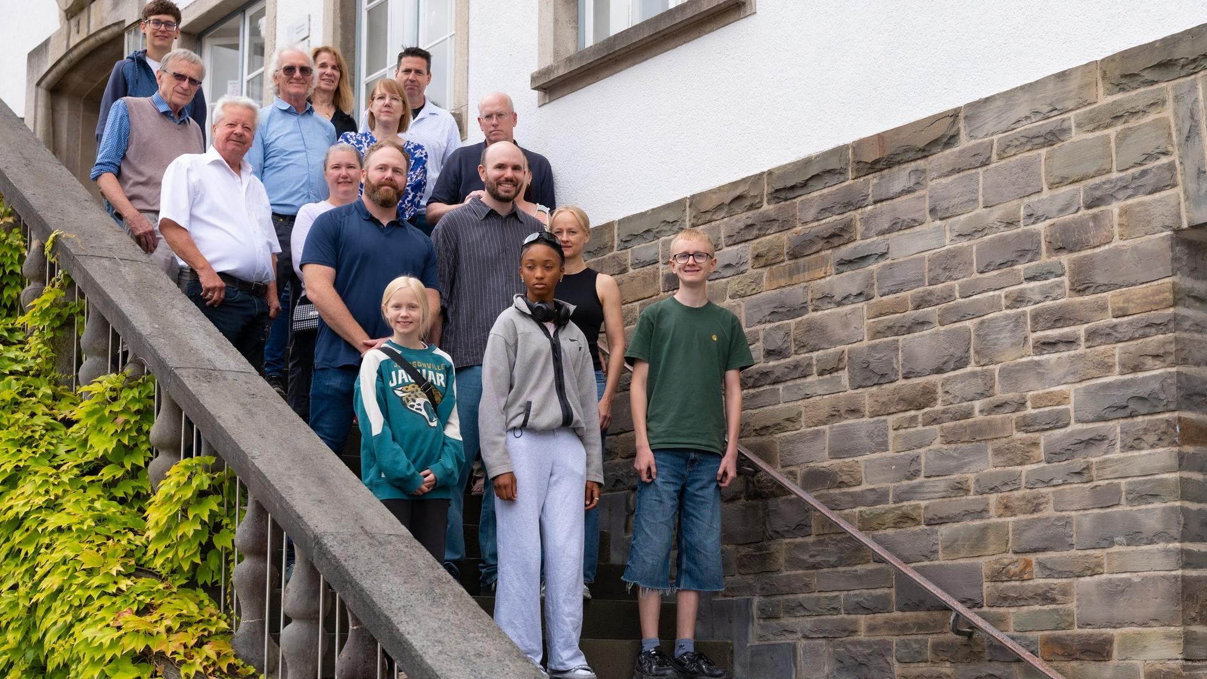

In 1880, ten-year-old Hermann Joseph Schulte emigrated from Wipperfürth to the United States. His descendants have now returned to visit the town in which their ancestor once lived.
They traveled from California, Colorado, Washington State, and Basel. Their goal: to visit the place that their great-, great-great-, and great-great-great-grandfather left in 1880 to seek his fortune in the “New World.” Thirteen members of the Frost family were invited to a small reception at Wipperfürth Town Hall, where they were welcomed by Deputy Mayor Lothar Palubitzki.
Jon Frost, an economist from Seattle who now lives in Basel with his wife Elisa and their two children, first made contact with Mayor Anne Loth by email several months ago. Frost and his parents [JF: and brother] had already visited Wipperfürth once before, in 2002. For other members of the widely scattered family, this is their first trip to Germany. Jon and his father Joe, who is also on the trip, are particularly interested in their family history.

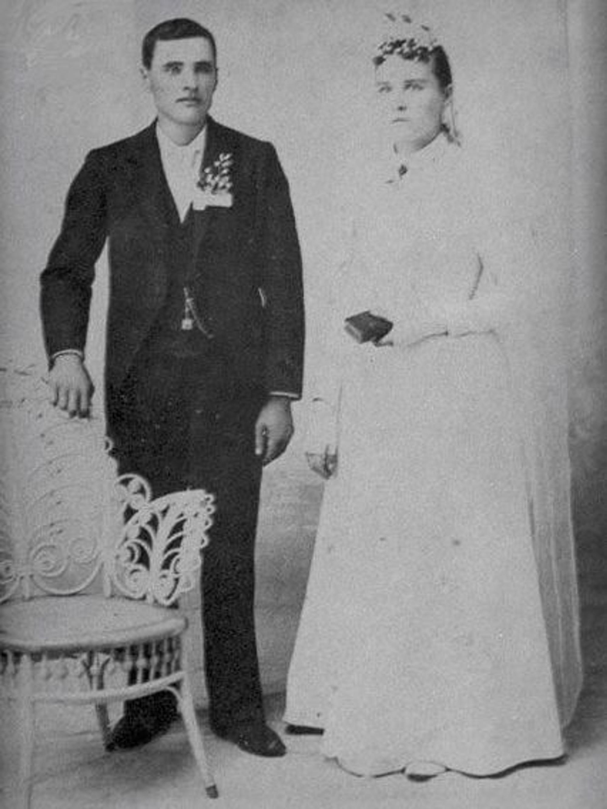
Photo: Hermann Joseph Schulte and his wife, Mary Elizabeth Sturbaum.
“My great-great-grandfather Johann Hermann Joseph Schulte was born in Wipperfürth in 1869 and emigrated with his family to Nebraska on May 22, 1880, at the age of ten,” Jon explains. Today, hundreds of Schulte descendants live in the United States. “The family is Catholic, and many of them had very large families,” says Joe Frost. In 1880 alone, around 250,000 Germans emigrated to the United States.
The fact that the Schultes ended up in the U.S. state of Nebraska was no coincidence. One of the major railroad companies deliberately sold land to people interested in emigrating—and did so while they were still in Germany. “A hectare of land cost 15 dollars,” Joe explains. Buyers simply did not know what they were getting for their money, or whether the land would be fertile or completely useless.
The land cost 15 dollars a hectare
Now, 146 years later, the Schulte descendants are retracing their family history. Over the past few months, Wipperfürth city archivist Sarah Zeppenfeld sent Jon Frost numerous copies of civil registry documents. Norbert Wegerhoff of the local heritage and history association also helped with the research.
The research revealed that Louise Walder-Schulte, the mother of Hermann Joseph Schulte, was born in 1841 in Niederscheveling, a village located between Wipperfürth and Kreuzberg. She also emigrated to the United States with the family and died in Nebraska in 1921.
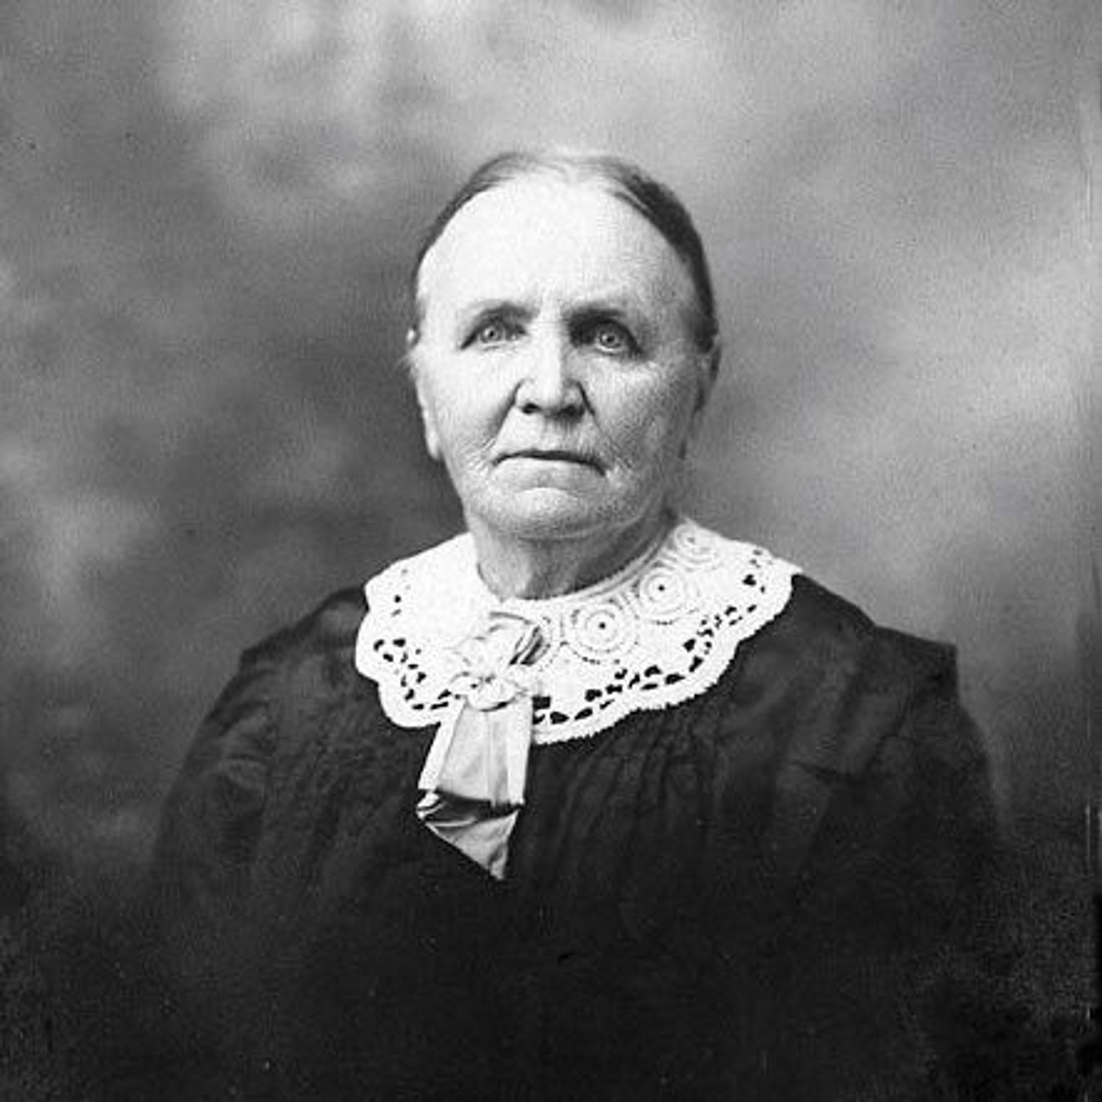
Photo: Louise Walder Schulte (born in Niederscheveling, Wipperfürth, in 1841; died in Nebraska in 1921), mother of Hermann Joseph Schulte.

One of her nephews, Wilhelm Hubert Walder (1877–1941), owned the Walder shoe store at Hochstraße 35 in Wipperfürth. The business apparently remained in operation until 1976.
Before the reception at Town Hall, Erich Kahl took the American family on a tour of St. Nicholas Church, showing them the old baptismal font and the church’s many statues of saints. Rose, another member of the family, noticed that many of the saints’ names were also popular first names within the family.
The Schulte descendants have also preserved a tradition to this day that is typically German. They celebrate St. Nicholas Day and leave their polished shoes outside their doors, where they are filled with small gifts. “For us, St. Nicholas is a family celebration where we all get together.”
While strolling through Wipperfürth’s old town, the Frost family came across Schulte Butcher Shop and learned that the Schulte Café once operated directly across the street for many years. It has not yet been established whether either business is connected to the same branch of the family.
The Frosts have, however, probably located the former family home of Hermann Joseph Schulte. It stands in Großblumberg, very close to the Neyetal Reservoir. According to family history, shortly before emigrating, the family gathered there for one final dinner together. And so the American family also stopped for a meal at the restaurant in Großblumberg.
Jon Frost studied in Munich and speaks perfect German. His cousin Matthew, who also joined the trip, spent four years in Bavaria as a U.S. soldier and looks back fondly on that time.
“The reception at Wipperfürth Town Hall was very special. We are delighted by the hospitality of the town,” says Jon Frost, expressing thanks on behalf of the family.

